We invite you to Poznań for the Stone Fair
The most important meeting of the stone industry on 20-23 November 2019
at the Poznań International Fair

The STONE Fair is the only event in Poland dedicated to stonemasons, which has been held continually for 11 years. MTP Group, as a leader of the trade fair industry and a partner in the area of business development, was the first to see the need to create a platform that would be a place for meetings of practitioners, exchange of experience, discussion and a contracting-friendly area.
The long tradition of the Stone trade fair and the experience of MTP Group allowed us to create a trade event which, in the opinion of both visitors and exhibitors, is recognised as the most important event in the stone industry. In principle, presence at this event is obligatory for anyone who wants to stand out from the competition, present their offer to professional customers or set trends which are followed.
Taking into account the exhibition space and the number of visitors and exhibitors, Stone is the largest stone exhibition in Central and Eastern Europe.
Why is it worth being here?
Business meetings in the surroundings of various colours, patterns and structures of stone from all over the world. Presentations of the cutting-edge solutions and machines for stone processing at the stands foster finalising of contracts and orders during the STONE Fair. An excellent place for “live” shows of machinery, tools and accessories for working of this raw material.
The presence of leading companies representing the industry attracts stonemason, stonemason workshop owners, monument conservators, designers and architects. More than half of the exhibitors are foreign companies.
Fair distinctive features:
- Sound business, flexible to customers’ needs
- Space of best proposals for the industry
- “Live” production at the fair
- Market novelties, latest technologies and products
- The most important event of the stone industry
Figures don't lie
- 76% of customers return to the fair
- 83% of customers satisfied with the fair
- 4 500 square metres of the exhibition space
The following companies have announced their participation in the fair, among others:
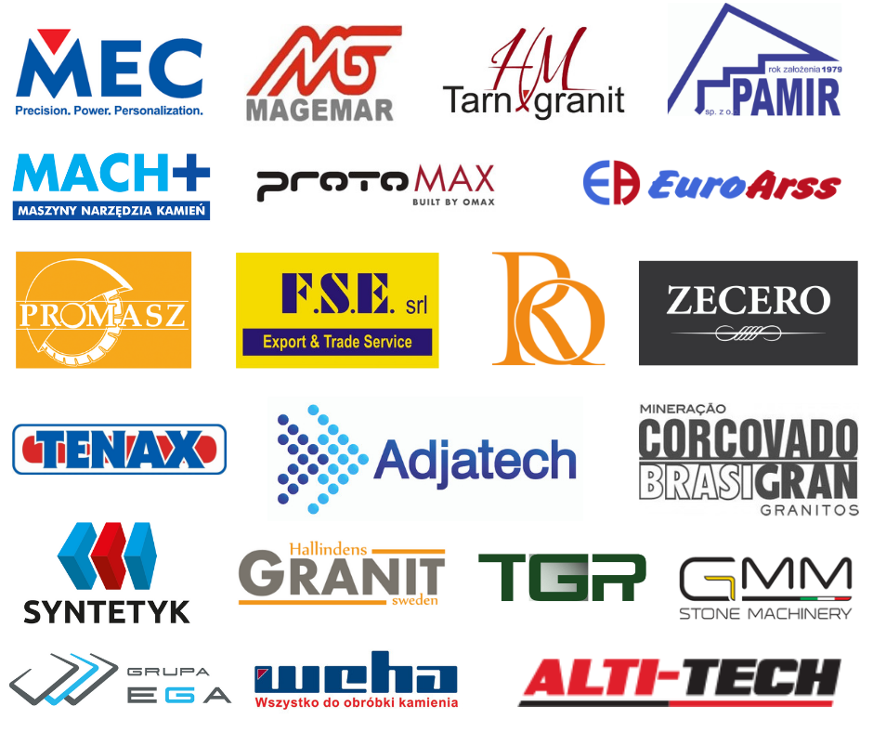
Further information: www.targistone.pl/en

